**Individual Weekly Report**

**Name: Simone Kang**

**Team:** Good AIM

**Date:** 3/3/25

| **Current Status** |
| --- |

1. What did you **personally** work on this past week?

| **Task** | **Status** | **Time Spent** |
| --- | --- | --- |
| Implement Google OAuth | DONE | 1-3hr |
| User accommodations | IN PROGRESS | >2.5 hr |
| Alerts | DONE | < 1hr |
| accessibility menu | IN PROGRESS | < 1hr |

Include **screenshots/graphics** to illustrate what you did this past week:

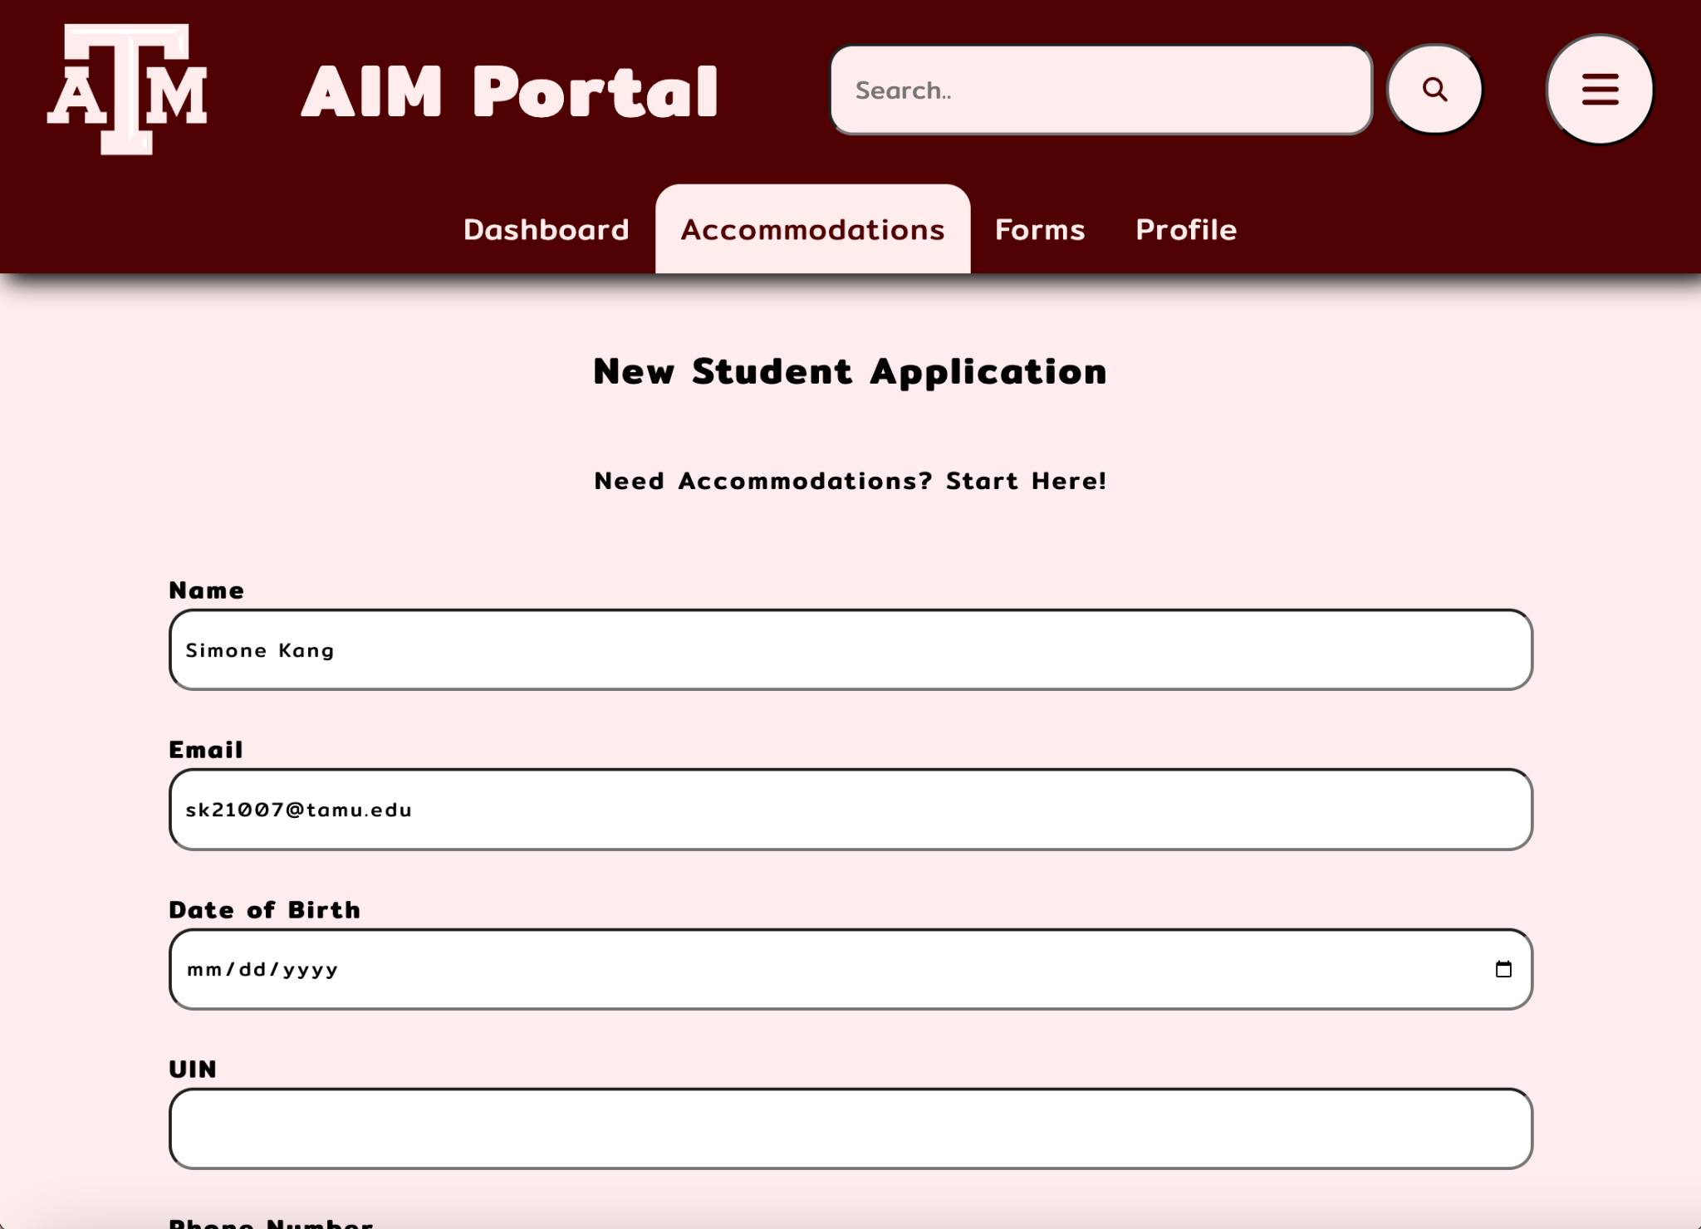

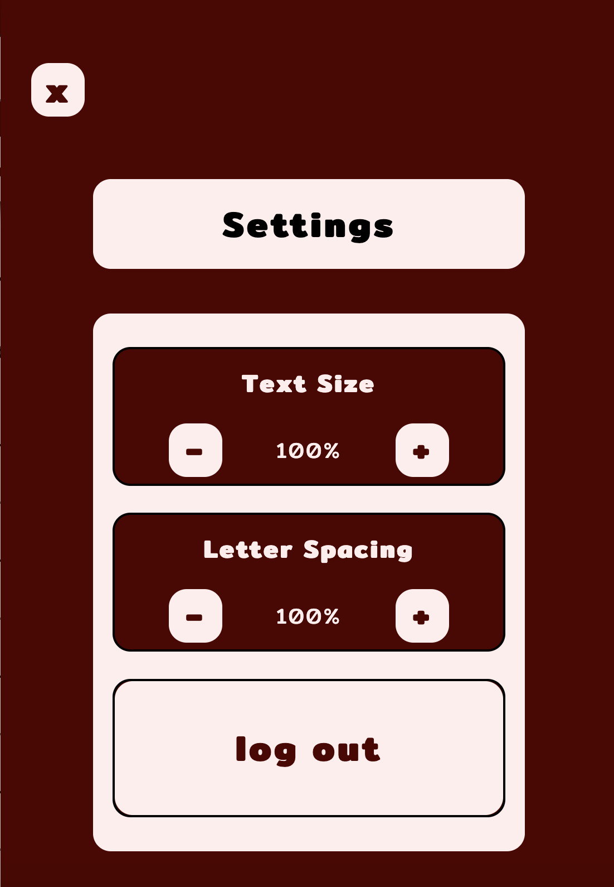

1. What problems did you run into? What is your plan for them?

There have been some issues with google oauth and using false emails. We’re still in the middle of debugging this so that we can adequately add to the base code.

1. What is the current overall project status from your perspective?

We’re not doing quite as well as I would have hoped. We didn’t get all of our sprint 1 tasks done, however it seems like we’ll be back on track after this second sprint.

1. How is your team functioning from your perspective?

The team is functioning well, I think we just need to put in more effort to status demos.

1. What new ideas did you have or skills did you develop this week?

Been using a screen reader for testing purposes, so learning to do that, and speaking with Justin about what specifically is different for everyday screen reader users vs occasional.

1. Who was your most awesome team member this week and why?

Our most awesome team member this week has been Shreyas & Paul. They’re doing a great job with backend management and transitioning over to ORM.

| **Plans for Next Week** |
| --- |

What are you going to work on this next week?

Finish up user accommodations, and accessibility settings for this sprint.